1. 区县网站所示位置改成对应的单位，比如阆中的，就改成“阆中市公共资源交易中心”，西充的就改成西充县公共资源交易中心：

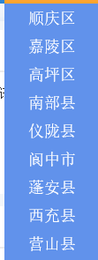

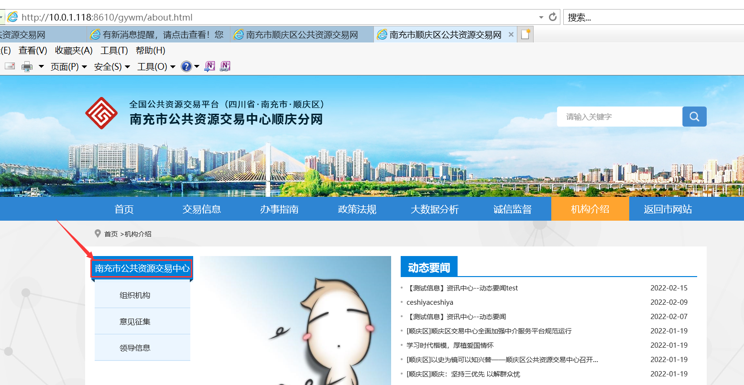

2、区县网站的所示图片，替换成附件的图片，并且对应链接配置如下（顺庆的已经换过图标了，只需配置一下跳转链接）：

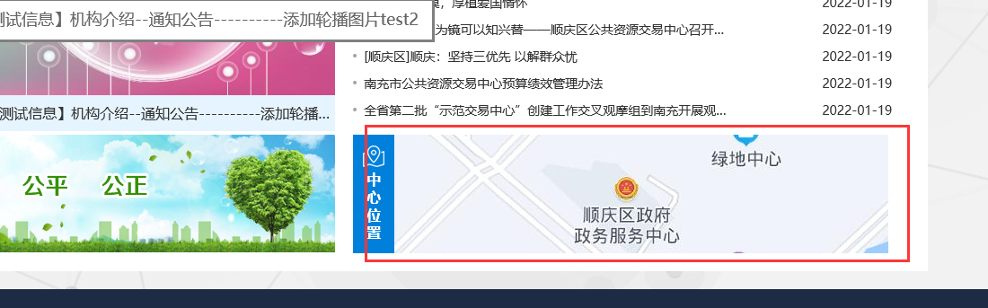

顺庆：

https://map.baidu.com/poi/%E9%A1%BA%E5%BA%86%E5%8C%BA%E4%BA%BA%E6%B0%91%E6%94%BF%E5%BA%9C%E6%94%BF%E5%8A%A1%E6%9C%8D%E5%8A%A1%E4%B8%AD%E5%BF%83/@11808804.44063352,3592305.9515841296,17.96z?uid=cc7510f22dcb92240f0e6b8a&info_merge=1&isBizPoi=false&ugc_type=3&ugc_ver=1&device_ratio=2&compat=1&pcevaname=pc4.1&querytype=detailConInfo&da_src=shareurl

高坪：

https://map.baidu.com/poi/%E5%8D%97%E5%85%85%E5%B8%82%E9%AB%98%E5%9D%AA%E5%8C%BA%E5%85%AC%E5%85%B1%E8%B5%84%E6%BA%90%E4%BA%A4%E6%98%93%E4%B8%AD%E5%BF%83/@11818293.755,3582131.28,19z?uid=a6e93e3ab8f51781c17da22c&ugc_type=3&ugc_ver=1&device_ratio=2&compat=1&pcevaname=pc4.1&querytype=detailConInfo&da_src=shareurl

仪陇：

https://map.baidu.com/poi/%E4%BB%AA%E9%99%87%E5%8E%BF%E5%85%AC%E5%85%B1%E8%B5%84%E6%BA%90%E4%BA%A4%E6%98%93%E4%B8%AD%E5%BF%83/@11835962.031245392,3646430.4038165044,20.09z?uid=4e21e1eb884bf9e1f503b85d&ugc_type=3&ugc_ver=1&device_ratio=2&compat=1&pcevaname=pc4.1&querytype=detailConInfo&da_src=shareurl

营山：

https://map.baidu.com/poi/%E8%90%A5%E5%B1%B1%E5%8E%BF%E5%85%AC%E5%85%B1%E8%B5%84%E6%BA%90%E4%BA%A4%E6%98%93%E4%B8%AD%E5%BF%83/@11863561.626558512,3621448.9894646574,21z?uid=fcf4406e138fb846e8e58219&ugc_type=3&ugc_ver=1&device_ratio=2&compat=1&pcevaname=pc4.1&querytype=detailConInfo&da_src=shareurl

蓬安：

https://map.baidu.com/poi/%E8%93%AC%E5%AE%89%E5%8E%BF%E5%85%AC%E5%85%B1%E8%B5%84%E6%BA%90%E4%BA%A4%E6%98%93%E4%B8%AD%E5%BF%83/@11846848.425,3614510.21,19z?uid=0844bc49d4cb12692b3a9fc3&ugc_type=3&ugc_ver=1&device_ratio=2&compat=1&pcevaname=pc4.1&querytype=detailConInfo&da_src=shareurl

西充：

https://map.baidu.com/poi/%E8%A5%BF%E5%85%85%E5%8E%BF%E5%85%AC%E5%85%B1%E8%B5%84%E6%BA%90%E4%BA%A4%E6%98%93%E4%B8%AD%E5%BF%83/@11788808.855,3609678.44,19.75z?uid=5e19748bbaa457e8f7b916da&ugc_type=3&ugc_ver=1&device_ratio=2&compat=1&pcevaname=pc4.1&querytype=detailConInfo&da_src=shareurl

嘉陵：

https://map.baidu.com/search/%E5%8D%97%E5%85%85%E5%B8%82%E5%98%89%E9%99%B5%E5%8C%BA%E5%98%89%E5%85%B4%E8%B7%AF57%E5%8F%B72%E6%A5%BC/@11808261.081008198,3580594.3522133036,19z?querytype=s&da_src=shareurl&wd=%E5%8D%97%E5%85%85%E5%B8%82%E5%98%89%E9%99%B5%E5%8C%BA%E5%98%89%E5%85%B4%E8%B7%AF57%E5%8F%B72%E6%A5%BC&c=291&src=0&pn=0&sug=0&l=19&b=(11788660.819679178,3609592.9321066886;11789005.09513897,3609746.934428082)&from=webmap&biz_forward=%7B%22scaler%22:2,%22styles%22:%22pl%22%7D&device_ratio=2

南部：

https://map.baidu.com/poi/%E5%8D%97%E9%83%A8%E5%8E%BF%E5%86%9C%E6%9D%91%E4%BA%A7%E6%9D%83%E4%BA%A4%E6%98%93%E4%B8%AD%E5%BF%83/@11804735.430291794,3656553.564772399,19.53z?uid=e4a511ed133b9895d8eced51&ugc_type=3&ugc_ver=1&device_ratio=2&compat=1&pcevaname=pc4.1&querytype=detailConInfo&da_src=shareurl

阆中：

https://map.baidu.com/search/%E9%98%86%E4%B8%AD%E5%B8%82%E5%85%AC%E5%85%B1%E8%B5%84%E6%BA%90%E4%BA%A4%E6%98%93%E4%B8%AD%E5%BF%83/@11758357.13938177,3633788.3600018546,10.11z?querytype=s&da_src=shareurl&wd=%E9%98%86%E4%B8%AD%E5%B8%82%E5%85%AC%E5%85%B1%E8%B5%84%E6%BA%90%E4%BA%A4%E6%98%93%E4%B8%AD%E5%BF%83&c=291&src=0&pn=0&sug=0&l=19&b=(11804523.83644054,3656461.4772728793;11804924.877990443,3656640.8723703315)&from=webmap&biz_forward=%7B%22scaler%22:2,%22styles%22:%22pl%22%7D&device_ratio=2